**WHY US?  
Reviews**

Please do it as in the page by changing certain places: <https://www.montway.com/montway-auto-transport-reviews>

**About us**

Dizayni shu pagedagidek bo’lsa bo’ladi: <https://www.montway.com/vision-and-mission>  **“We stand for quality to deliver the best possible auto transport experience”**

**OUR VISION**

Our ultimate goal is to create a system where everyone using our service is 100% satisfied and will surely return for future needs.

**OUR MISSION**

We strive to provide professional service to make sure each of our customers gets 5-star vehicle-shipping experience.

**OUR TOP VALUE**Our core value is to have a FAMILY TEAM where all members use “WE” instead of “I” to deal with any case.

Pastidan manashu qismni quyish kk:

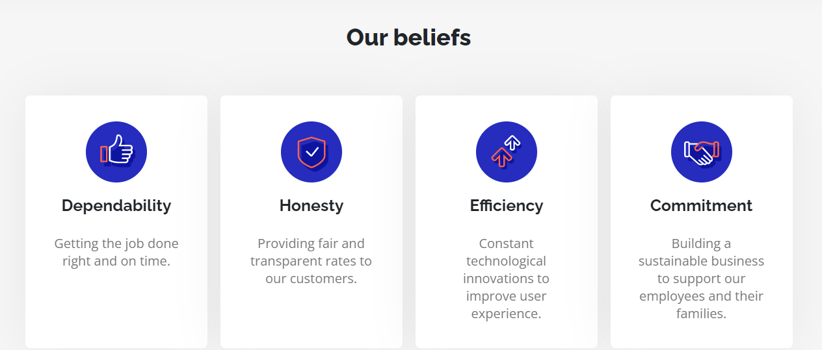

**Our Team**

Bu qismi o’zimizning vebsaytdagidek bo’laversin